2. Directions: Study the following picture carefully and write an essay entitled “Cultures -- National and International”. In the essay you should 1) describe the picture and interpret its meaning, and 2) give your comment on the phenomenon.
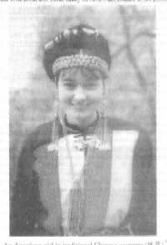
An American girl in traditional Chinese costume (服装)

